

ABDULLAH GÜL UNIVERSITY

DEPARTMENT OF CIVIL ENGINEERING

CE 482 – COMPUTATIONAL STRUCTURAL ANALYSIS AND DESIGN

**“ETABS-BASED STRUCTURAL ANALYSIS AND DESIGN OF A SCHOOL BUILDING”**

**STUDENT’S:**

**NAME-SURNAME:** ELİF ARSLAN

**ID NUMBER:** 2011031003

**INSTRUCTOR:** *********

**Table of Contents**

1. Introduction
2. Project Scope and Objectives
3. Structural Modeling in ETABS  
   3.1. Grid and Story Definition  
   3.2. Material Properties  
   3.3. Frame and Slab Sections
4. Load Definitions  
   4.1. Load Patterns  
   4.2. Load Combinations
5. Seismic Data Input  
   5.1. AFAD-Based Spectral Parameters  
   5.2. Response Spectrum Function
6. Modal Analysis  
   6.1. Natural Period and Mode Shapes  
   6.2. Interpretation of Results
7. Influence of Section Properties on Dynamic Behavior
8. 3D Model Visualization
9. Conclusion
10. References

**1. Introduction**

This report presents a detailed technical documentation of the structural modeling and dynamic analysis of a reinforced concrete school building carried out using the ETABS software. The objective is to assess the building's seismic performance by conducting modal analysis and response spectrum analysis in accordance with the Turkish Seismic Code (2018). The seismic parameters were taken from AFAD’s Earthquake Hazard Map, specifically for Elazığ/Çaydaçıra Mahallesi. All modeling, loading, and interpretation of results were conducted by Elif Arslan as part of the CE 482 coursework.

**2. Project Scope and Objectives**

The main goals of the project are:

* To create a 3D finite element model of the school building in ETABS.
* To define material, section, and geometric properties accurately.
* To input gravitational and seismic loads.
* To perform modal analysis and determine the natural periods and mode shapes.
* To understand how the structure responds dynamically under seismic loading.
* To interpret the influence of geometric and section properties on dynamic response.

**3. Structural Modeling in ETABS**

**3.1. Grid and Story Definition**

A regular grid system was established based on the architectural plan. Grid lines were spaced at intervals of 4.3 m, 4 m, and 3.4 m along the X-axis, and 4.2 m to 4.5 m along the Y-axis. The story height was adjusted specifically for the student Elif Arslan, with the total building height being Z – 0.4 m.

**3.2. Material Properties**

The material properties were defined using the “Define > Material Properties” feature in ETABS:

* Concrete: C30, with an elastic modulus of approximately 32,500 MPa;
* Reinforcement Steel: B420S, with a yield strength of 420 MPa and elastic modulus of 200,000 MPa.

**metin, ekran görüntüsü, yazılım, bilgisayar simgesi içeren bir resim

Açıklama otomatik olarak oluşturuldu**

**Figure 1.** Assigning material properties for C30 concrete and B420S steel using the “Define Materials” feature.

**3.3. Frame and Slab Sections**

All beams and columns were created using custom frame sections. Beams had rectangular cross-sections (e.g., 30x60 cm), and columns were modeled with square or rectangular sections (e.g., 40x40 cm, 50x40 cm). Floor slabs were modeled using shell elements with a uniform thickness of 15 cm, defined in “Slab Sections.”

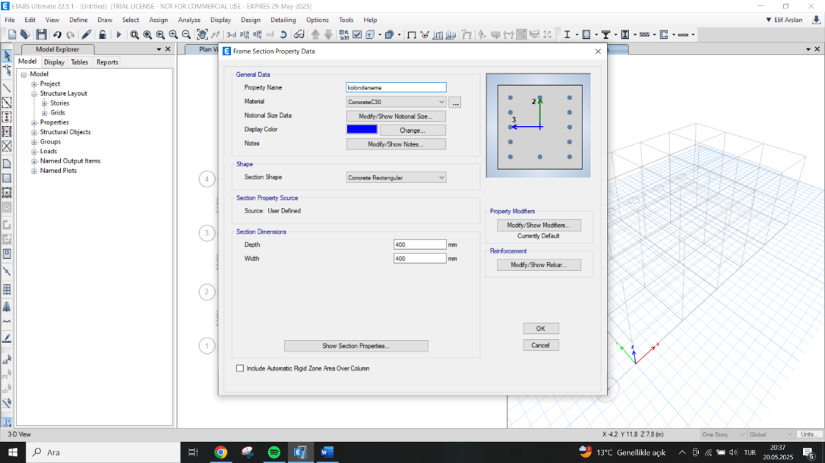

**Figure 2.** Creating custom beam and column sections under “Define > Frame Sections.”

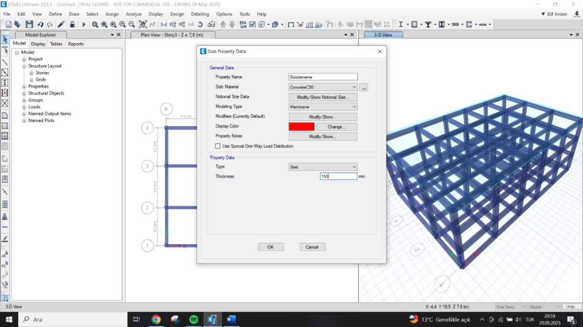

**Figure 3.** Creating slab sections under “Define > Section Properties > Slab Sections.”

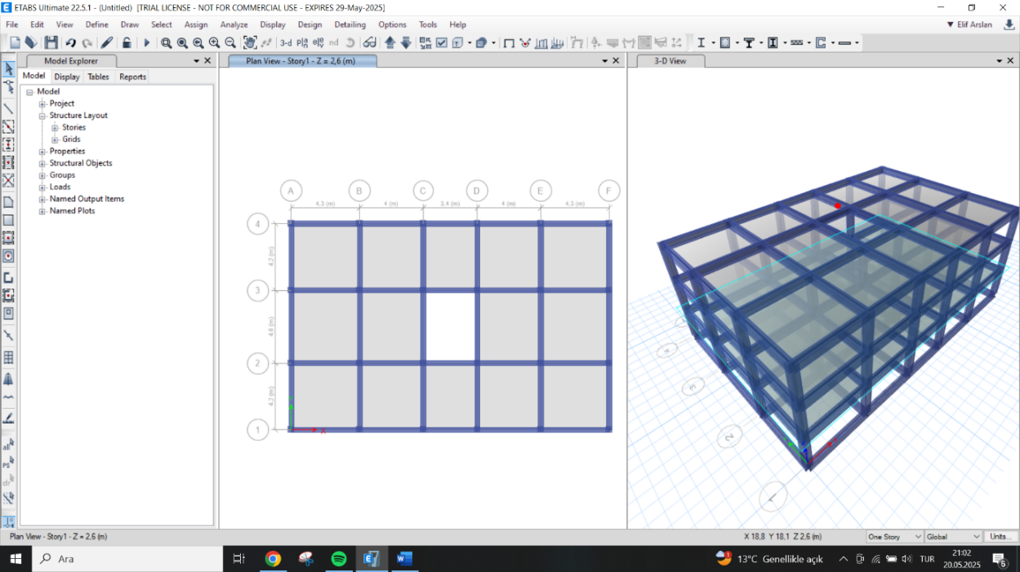

**Figure 4. Slab is added to the structure.**

**4. Load Definitions**

**4.1. Load Patterns**  
Dead Load (DL) and Live Load (LL) were defined. Self-weight was automatically included.

**4.2. Load Combinations**  
Load combinations were defined to evaluate ultimate limit states. The governing combination was:  
**Pu = 1.2 DL + 1.4 LL**

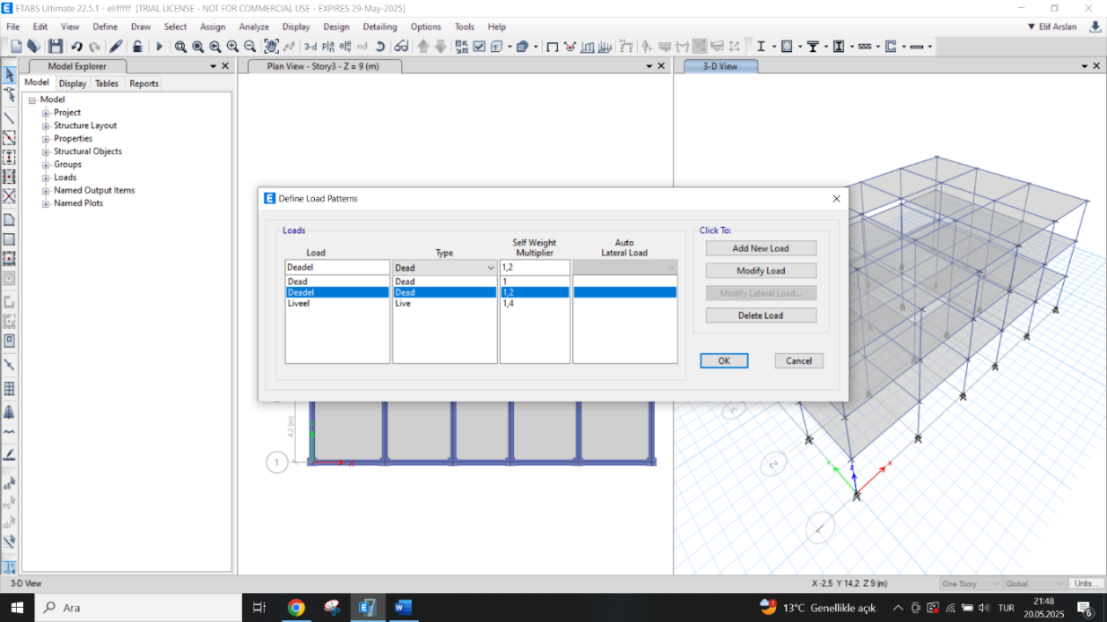

**Figure 5.** Inputting Dead and Live Load patterns under “Define > Load Patterns.”

**5. Seismic Data Input**

**5.1. AFAD-Based Spectral Parameters**

Using AFAD’s “Türkiye Deprem Tehlike Haritası,” site-specific seismic coefficients were defined:

* SDS = 1.000
* SD1 = 0.517
* Soil Type = ZD  
  These values were entered in accordance with Turkish Earthquake Code 2018.

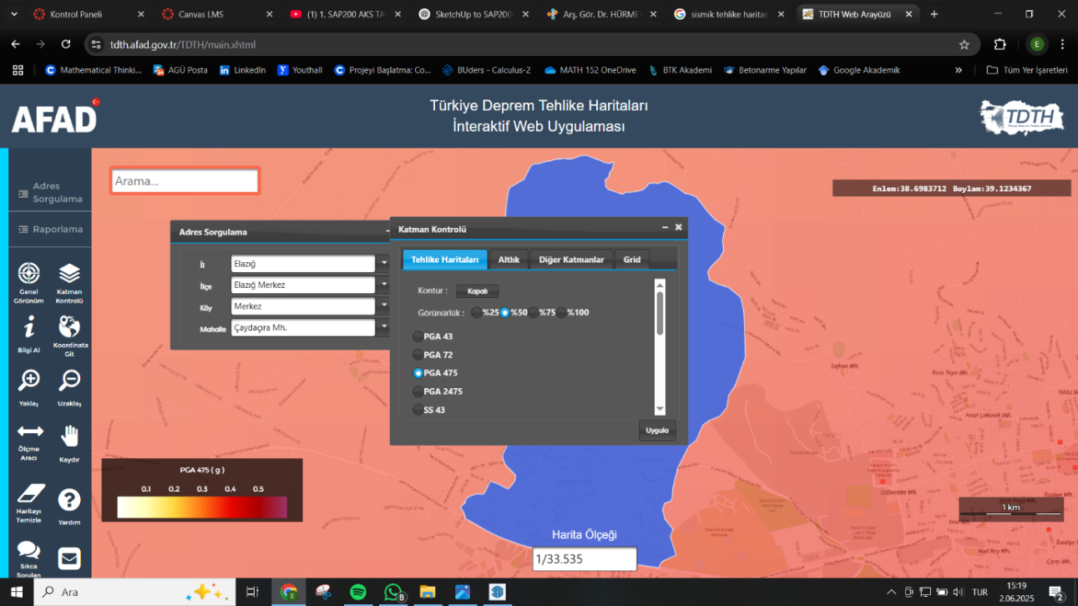

**Figure 6.** AFAD seismic hazard website

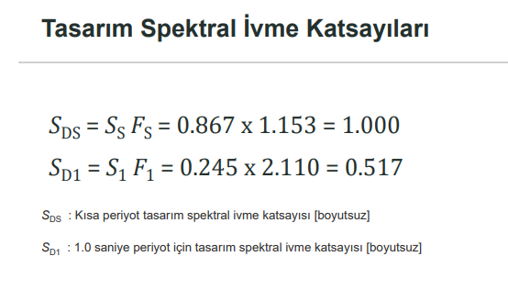

**Figure 7.** AFAD seismic hazard report for Elazığ/Çaydaçıra neighborhood (SDS, SD1, and soil class ZD values).

**5.2. Response Spectrum Function**

The elastic response spectrum function was created using these coefficients in “Define > Functions > Response Spectrum.” A 5% damping ratio was considered for typical reinforced concrete structures.

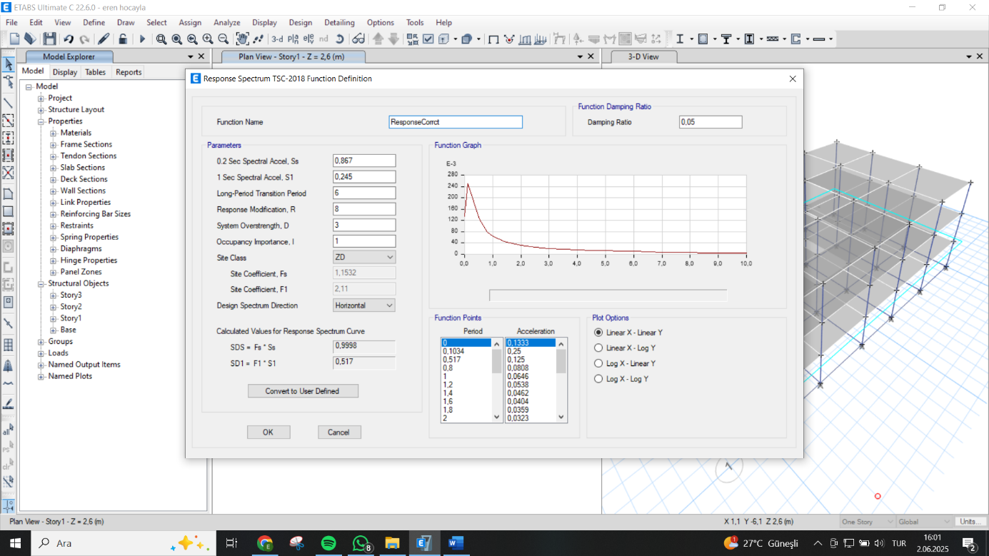

**Figure 8.** Defining a custom response spectrum function based on AFAD data with 5% damping.

**6. Modal Analysis**

**6.1. Natural Period and Mode Shapes**

Modal analysis was conducted via the eigenvalue method. The first mode period was obtained as approximately 0.253 seconds, which is consistent with the target of 0.3 s. A total of 12 modes were evaluated to capture over 90% mass participation.

metin, ekran görüntüsü, yazılım, bilgisayar simgesi içeren bir resim

Açıklama otomatik olarak oluşturuldu

**Figure 9.** Mode shapes of the building – Mode 1

**6.2. Interpretation of Results**

Animation of mode shapes was done using the “Start Animation” tool. The lateral deformation of the building was predominantly translational in Mode 1 (X-direction) and torsional in higher modes. The mode shape profiles aligned with expectations for a regular-plan RC building.

**7. Influence of Section Properties on Dynamic Behavior**

To evaluate the sensitivity of dynamic response to section dimensions, various parametric studies were performed:

* **Effect of Column Cross-Section**: Increasing the column dimensions from 40x40 cm to 50x50 cm reduced the fundamental period from 0.253 s to 0.229 s, indicating increased lateral stiffness.
* **Effect of Beam Size**: Altering beam sections had a marginal effect on the period, but significantly influenced the mass distribution and torsional response.
* **Slab Thickness**: Increasing slab thickness marginally affected the mass but not the stiffness. The modal period shifted slightly (less than 3%).

These findings demonstrate that column cross-sectional area has the most prominent impact on lateral stiffness and thus the period of vibration, validating basic structural dynamics theory.

**8. 3D Model Visualization**

The 3D model in ETABS was reviewed for continuity, proper connectivity at nodes, and load path verification. Using “3D View,” deformation shapes were observed dynamically under animated mode shapes. All components including beams, columns, and slabs behaved as expected.

**9. Conclusion**

The ETABS-based analysis for the CE 482 school building project yielded significant insights into the structure’s dynamic behavior. The model was constructed based on reliable material and geometry definitions, and the modal analysis provided critical data for seismic design. Adjusting section properties such as column size effectively demonstrated changes in period and lateral stiffness. The first natural period (0.253 s) aligned with expectations, and the use of AFAD data ensured accurate regional seismic representation.

This modeling experience enhanced both software proficiency and structural understanding, offering a solid foundation for subsequent detailed design steps.

**10. References**

* Turkish Earthquake Code (2018)
* TS500: Requirements for Design and Construction of Reinforced Concrete Structures
* TS498: Design Loads for Buildings
* AFAD Seismic Hazard Map: [https://tdth.afad.gov.tr](https://tdth.afad.gov.tr/)
* Computers and Structures, Inc. (ETABS v22.5.1 User Manual)